Test Case: tc001_SPX_Dev5_Crear_Requisicion_Spot_Tipo_Cobro_CC
Step 1 - Enter username and password and click to button Enter : Credentials Entered
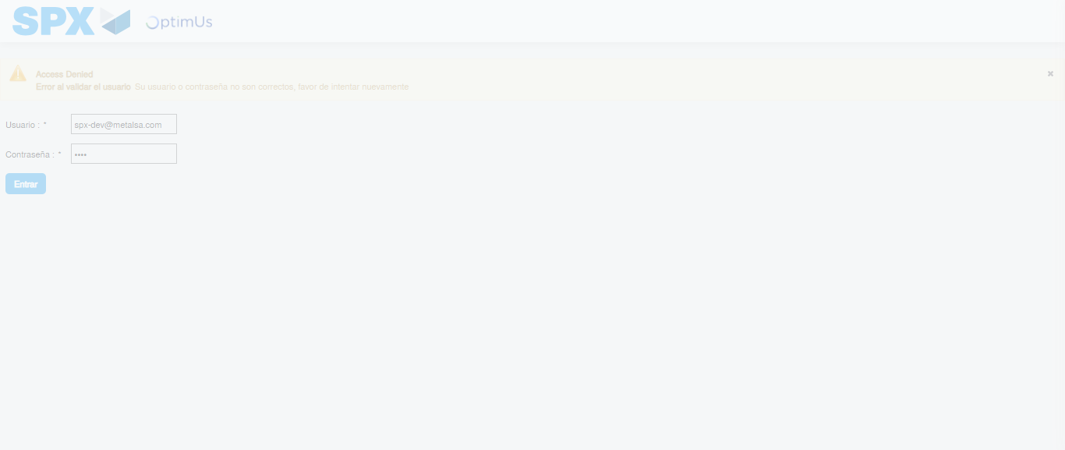Image file-name: QC_Testing-tc001_SPX_Dev5_Crear_Requisicion_Spot_Tipo_Cobro_CC-1783980940539

Step 2 - Select to UEN and Access to Spot Buy Requisitions : UEN Correctly selected and Correct access
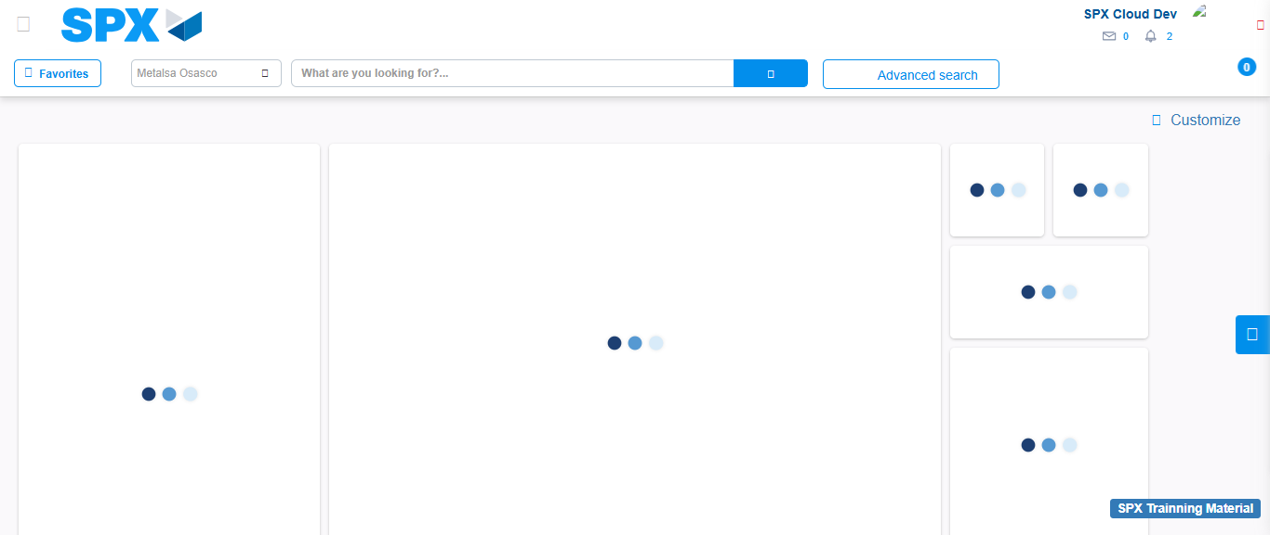Image file-name: QC_Testing-tc001_SPX_Dev5_Crear_Requisicion_Spot_Tipo_Cobro_CC-1783980971227

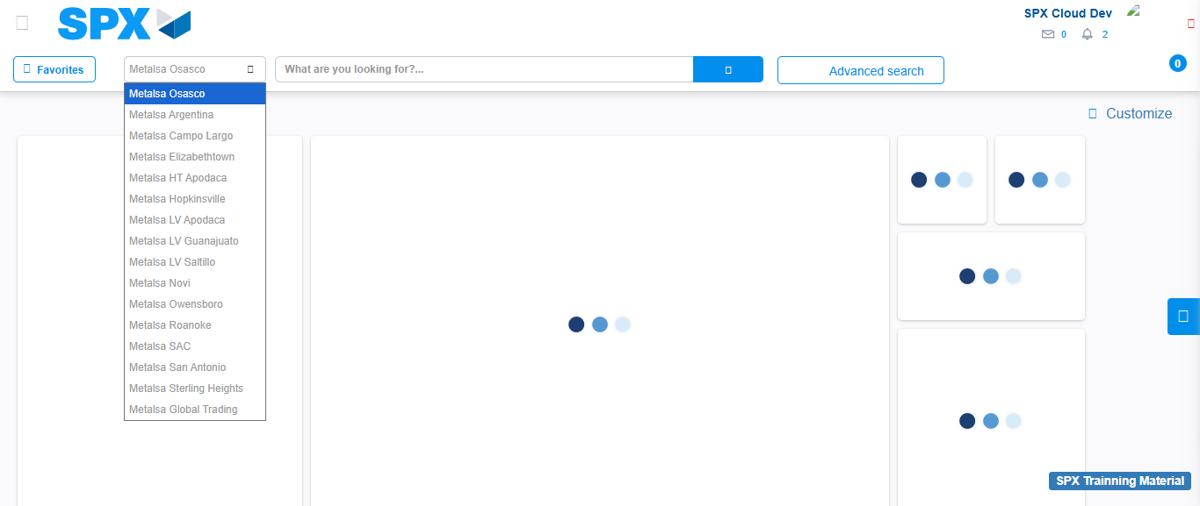Image file-name: QC_Testing-tc001_SPX_Dev5_Crear_Requisicion_Spot_Tipo_Cobro_CC-1783980973692

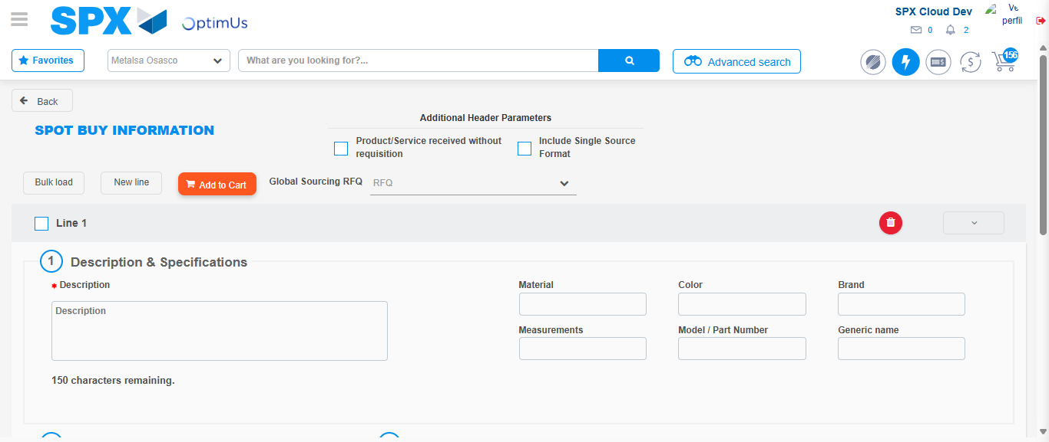Image file-name: QC_Testing-tc001_SPX_Dev5_Crear_Requisicion_Spot_Tipo_Cobro_CC-1783980988027

Step 3 - Data Capture Spot Buy Requisition : Data captured correctly
Image file-name: QC_Testing-tc001_SPX_Dev5_Crear_Requisicion_Spot_Tipo_Cobro_CC-1783980988274

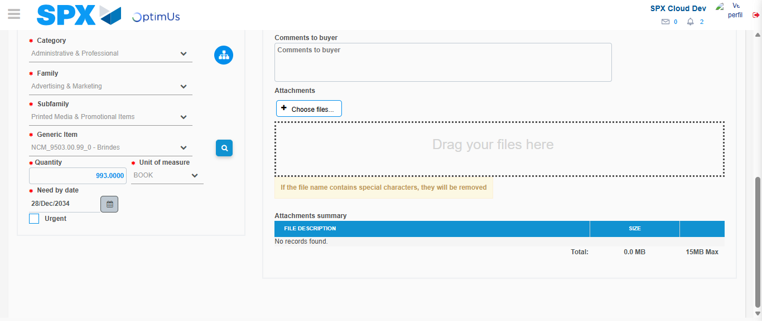Image file-name: QC_Testing-tc001_SPX_Dev5_Crear_Requisicion_Spot_Tipo_Cobro_CC-1783981000180

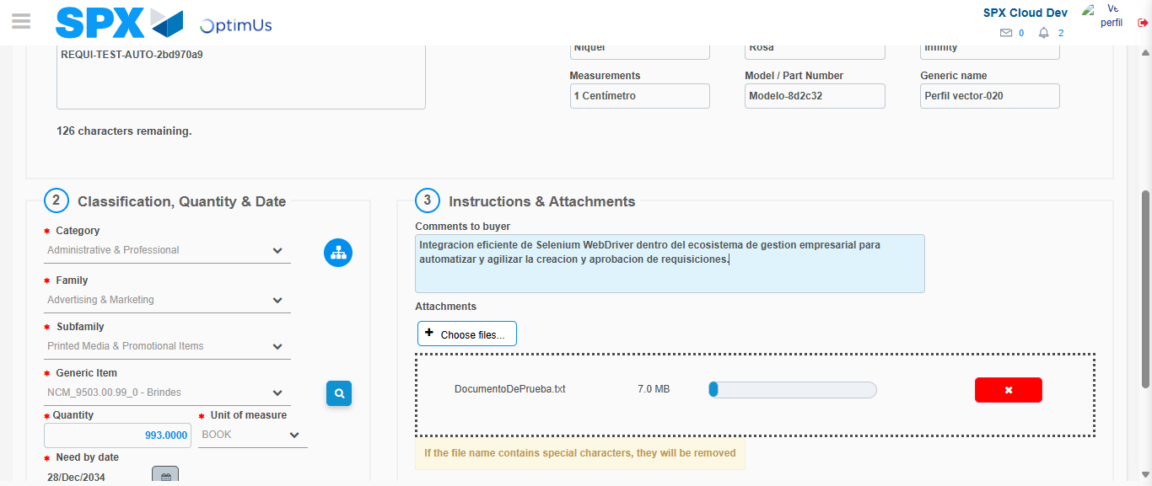Image file-name: QC_Testing-tc001_SPX_Dev5_Crear_Requisicion_Spot_Tipo_Cobro_CC-1783981000893

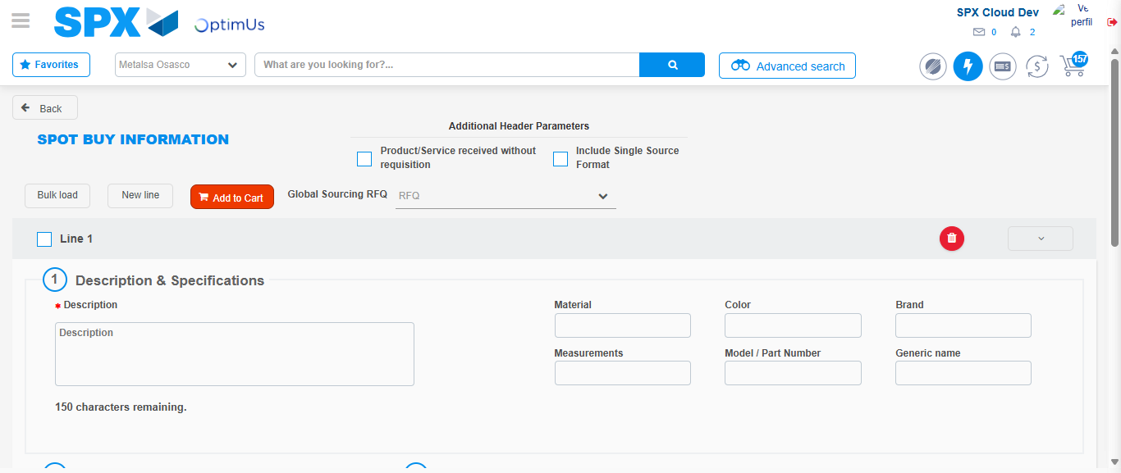Image file-name: QC_Testing-tc001_SPX_Dev5_Crear_Requisicion_Spot_Tipo_Cobro_CC-1783981010898

Step 7 - Return to Main Page SPX : Return to Main Page SPX
Image file-name: QC_Testing-tc001_SPX_Dev5_Crear_Requisicion_Spot_Tipo_Cobro_CC-1783980971227

Image file-name: QC_Testing-tc001_SPX_Dev5_Crear_Requisicion_Spot_Tipo_Cobro_CC-1783980973692

Image file-name: QC_Testing-tc001_SPX_Dev5_Crear_Requisicion_Spot_Tipo_Cobro_CC-1783980988027

Image file-name: QC_Testing-tc001_SPX_Dev5_Crear_Requisicion_Spot_Tipo_Cobro_CC-1783981013116

Image file-name: QC_Testing-tc001_SPX_Dev5_Crear_Requisicion_Spot_Tipo_Cobro_CC-1783981013286

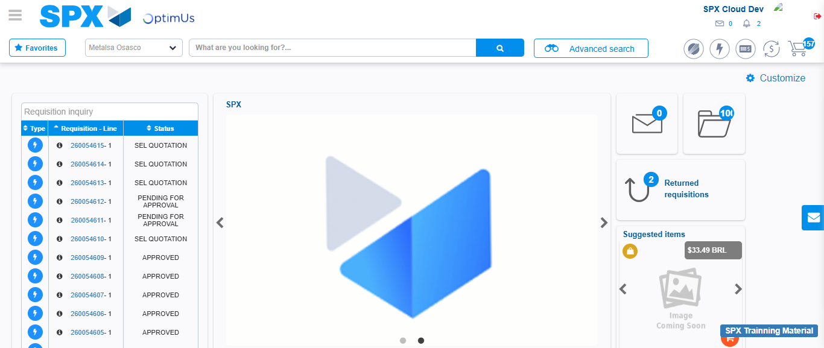Image file-name: QC_Testing-tc001_SPX_Dev5_Crear_Requisicion_Spot_Tipo_Cobro_CC-1783981034290

Step 8 - Log Out : Log Out SPX
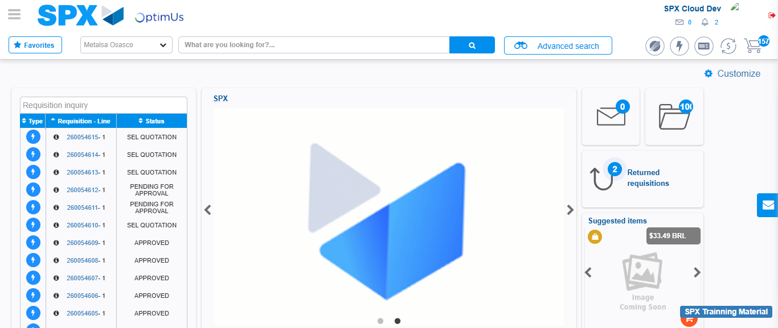Image file-name: QC_Testing-tc001_SPX_Dev5_Crear_Requisicion_Spot_Tipo_Cobro_CC-1783981034594

